Proposal

Project Description:

Finish maintenance coat on the vestibule entryway at 90 Park St. Brookline MA

Project Location:  90 Park St.  Brookline MA | 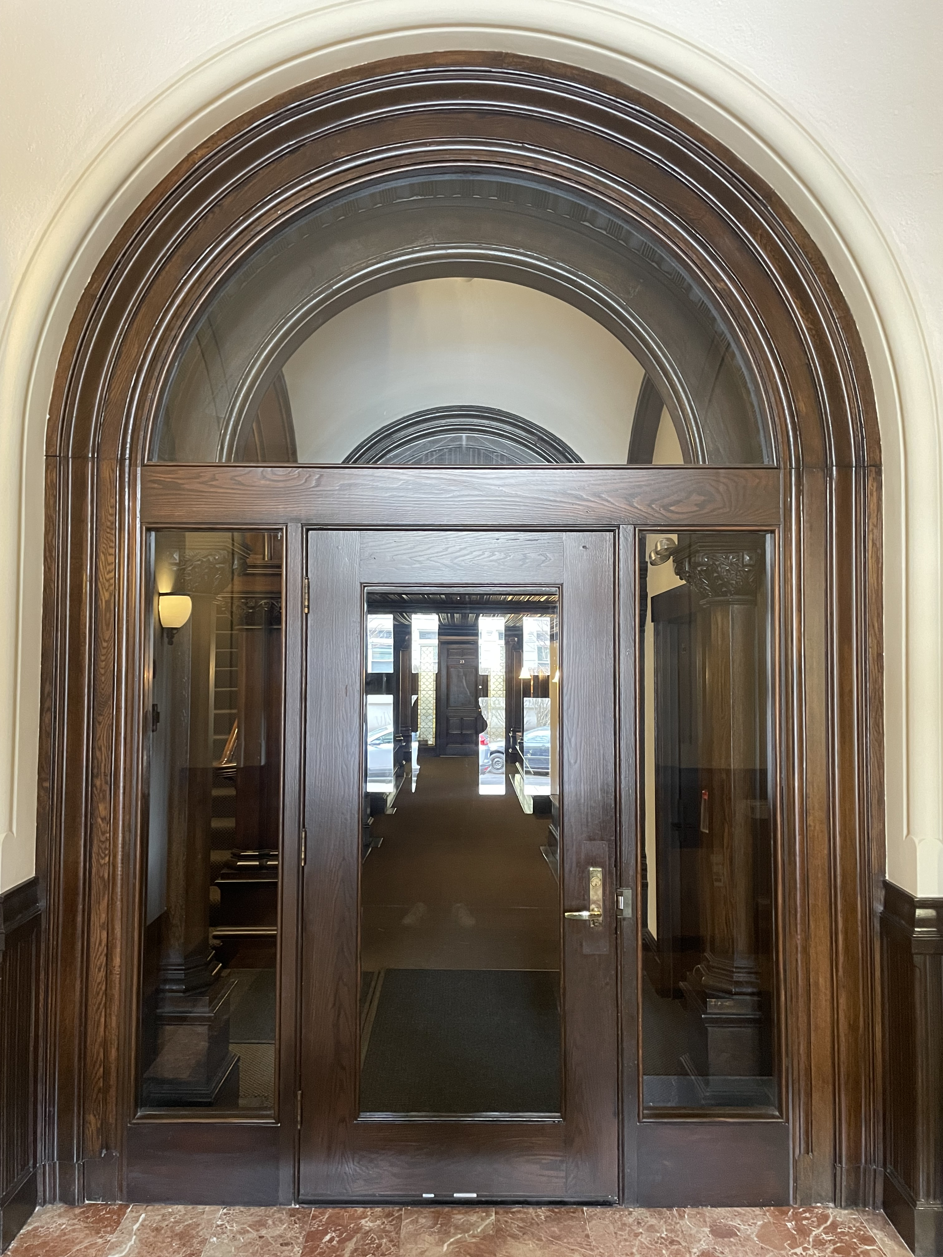
Customer Contact:
Nancy
90 Park St. Brookline MA
6177318121
90parkstreet@gmail.com

**current topcoat on the door is very close to pealing off, and may need to be removed before top coating the door
TERMS
Materials & Hardware
All material costs are included in this proposal
**Hardware Cost is not included in this proposal
Logistics & Project Timeline
Work Location: All work is to be performed On-site at 90 Park Street Brookline MA
Project Duration: 1-2 weeks (presumed 7.5 work days)
Planned Start Date: Scheduling is to take place immediately upon approval of this proposal with anticipated start date in Spring 2025
Payment Schedule
50% deposit upon project approval
25% before the Finishing phase is to begin (50% of project)
25% upon project completion

Please note: Above are the preferred payment terms, however Payment Schedule terms are negotiable
Best regards,
Vsevolod Sam Tsodokov
Principal/ Co-Founder
Boston Door Company
info@bostondoorcompany.net
(617) 233-2446

